# Set Up Selenium Grid

Download Selenium standalone Server jar file from <https://www.seleniumhq.org/download/>link

# java -jar selenium-server-4.10.0.jar hub

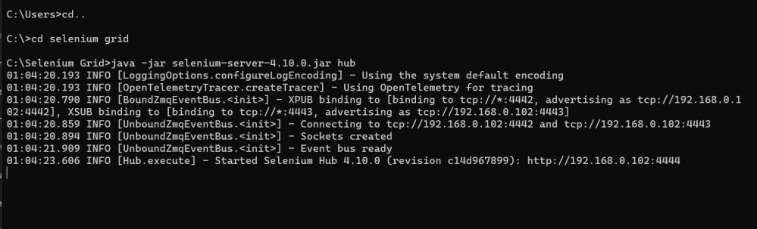

Open chrome browser - Enter URL as http://localhost:4444

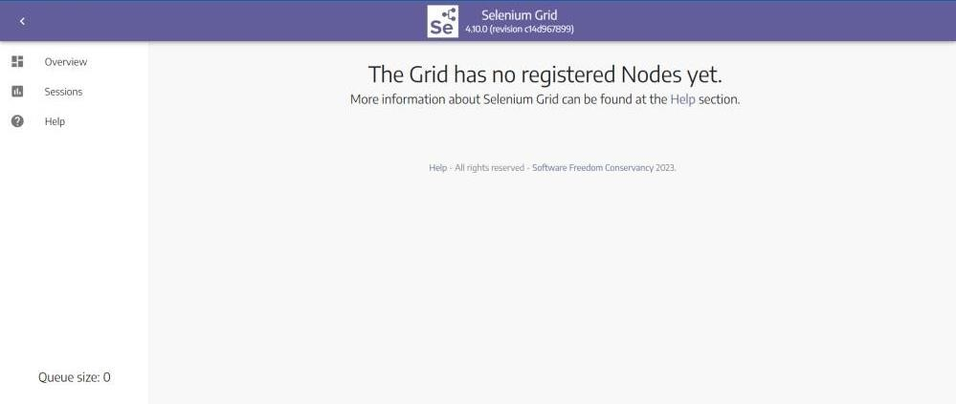

java - Dwebdriver.chrome.driver=C:\Users\Nivetha\Downloads\chromedriver - jar selenium-server-4.10.0.jar node

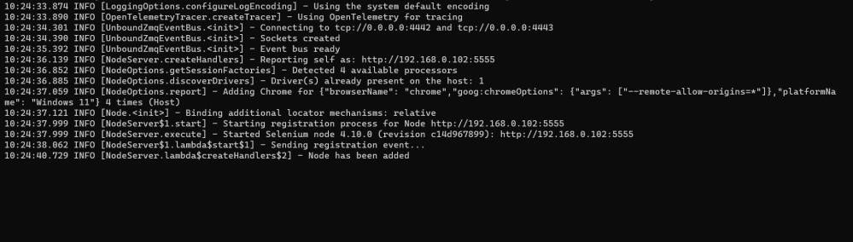

Open chrome browser - Enter URL as http://localhost:4444

